1. I can see that you have re-label the academic Appraisal to Institution of learning Appraisal which is good, but I can’t find the other “Appraisal model” which is meant for Companies and public/civil organization staff appraisal where they are strictly non-academic staff. For this model you are you use only the “Non-academic Appraisal model” found in the Institution of learning appraisal because the non-academic staff here fits with those in the company and public/civil servant organization.
2. With regards Pricing model, you haven’t added the section that was removed (that has to do with the request of the maintenance model) needed for the payment of the maintenance model as it isn’t part of the plan for Academic software product and Public/Civil organization software product.
3. The above when used is accepted but where the reverse is as found in the example below the save shouldn’t activate and there should be a message to lit him/her know that the rule is $λ<μ$ as seen below
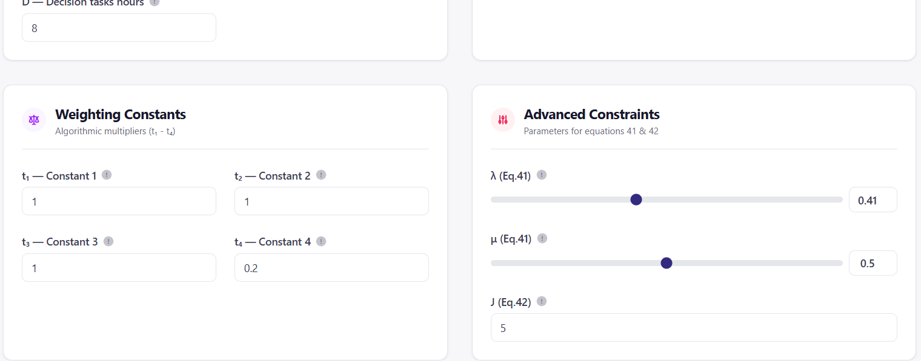
In the job done by my hiring manager please ensure that $λ$ is never set greater or equal to $μ$ where the below example is set it should be automatically flagged.
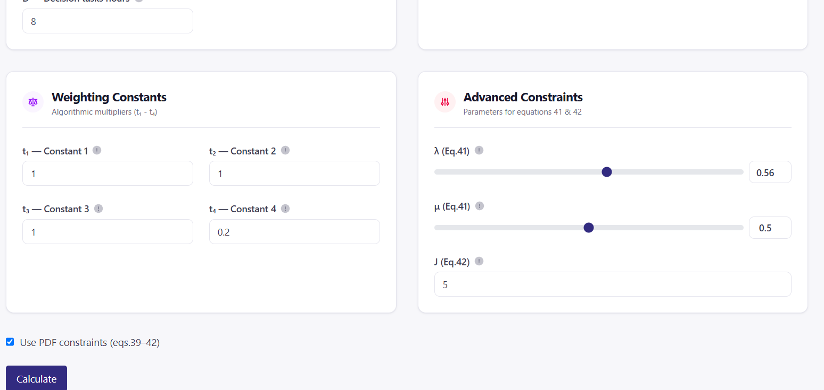
4. The below figure is what is obtained from the personnel Utilization model.
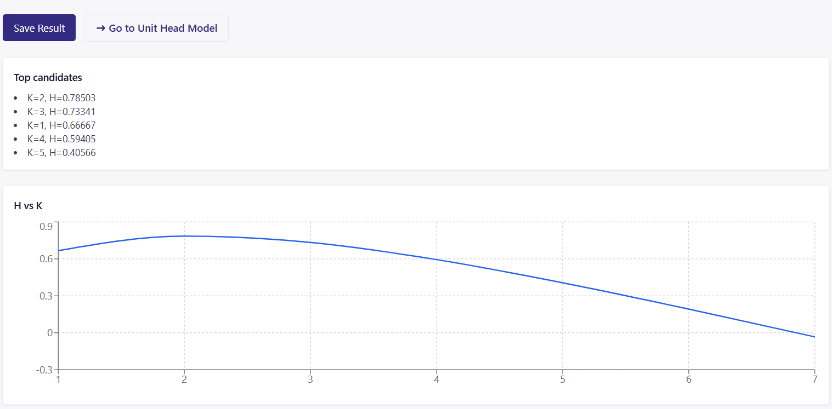
Fig. 4.1
You will notice the results of K and H above. It is only the first result which is the Max that is needed and saved into the history chart for any run and this was well captured by my Hiring manager. See the History figure below.
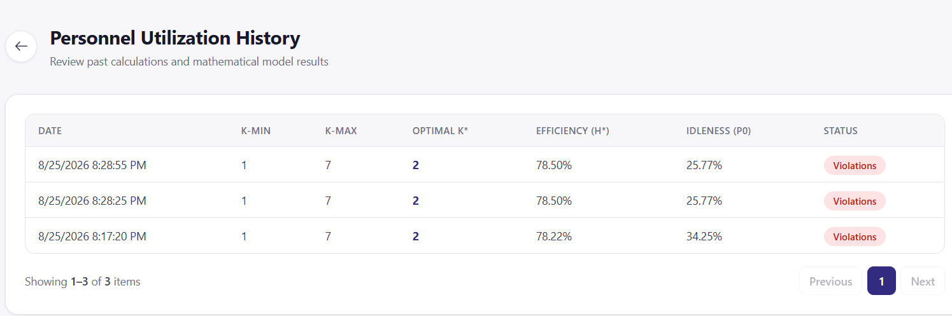
Fig 4.2
Please, include a remove option button in each stored record so that when they record a wrong evaluation and when they are getting too much of the recorded data that they don’t need they can manually delete those they don’t want because a good history record will be needed in the determination of the prediction into the future to determine the number of additional staff needed in the organization in the future if all parameters are as determined. See the figure below for an example in another useful are as found in fig 4.1 (Go to Head model Tab)
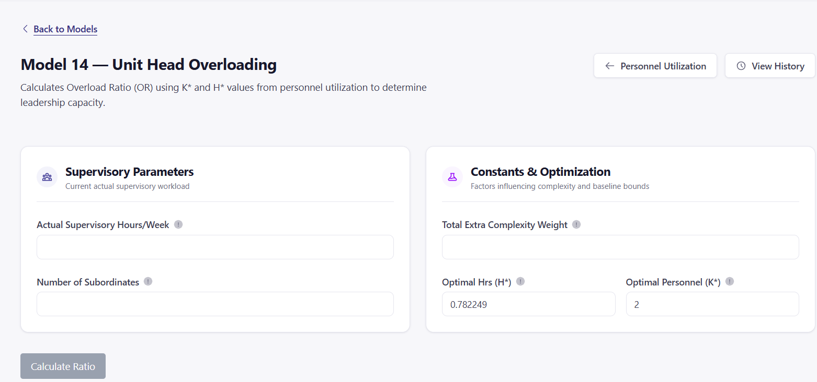
You will find that to run any model the vital two values needed are the $λ$ and the $μ$ values as we will need them also for the organization structure model. Just take note. You will find that optimal H* and and its corresponding K* value are the two values in the above figure that was evaluated earlier which is used to determine the Unit head overload. I would love where they are given the opportunity to select from the personnel Utilization history, which of these computed and recorded values they want to fill the Optimal Hrs (H*) field and the Optimal personnel (K*) field above with and as will also be needed in the Organization structure model.
5. The below figure is what is obtained from the Redundancy Index model (At the Supervision cost tab).
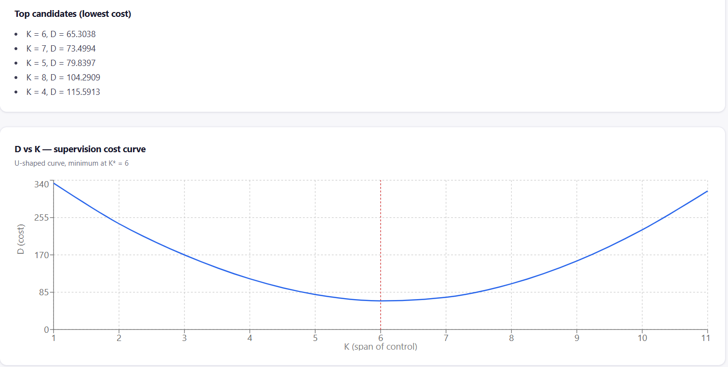
Fig. 5.1
You will notice the results of K and D above (are related to the minimum value from the plot). It is only the first result which is the Min that is needed and saved into the history chart for any run and this was well captured by my Hiring manager. See the History figure below.
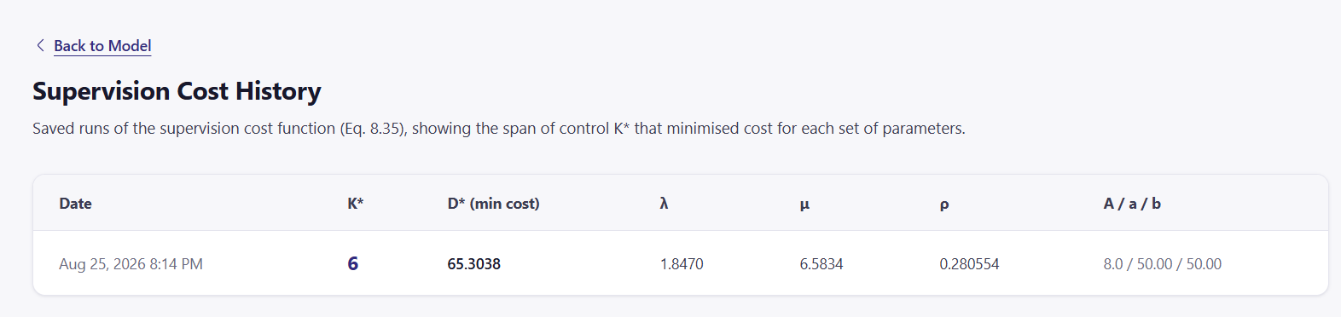
Fig 5.2
Please, include a remove option button in each stored record so that when they record a wrong evaluation and when they are getting too much of the recorded data that they don’t need they can manually delete them because a good history record is needed. See the figure below for an example in another useful area as found in fig 5.3
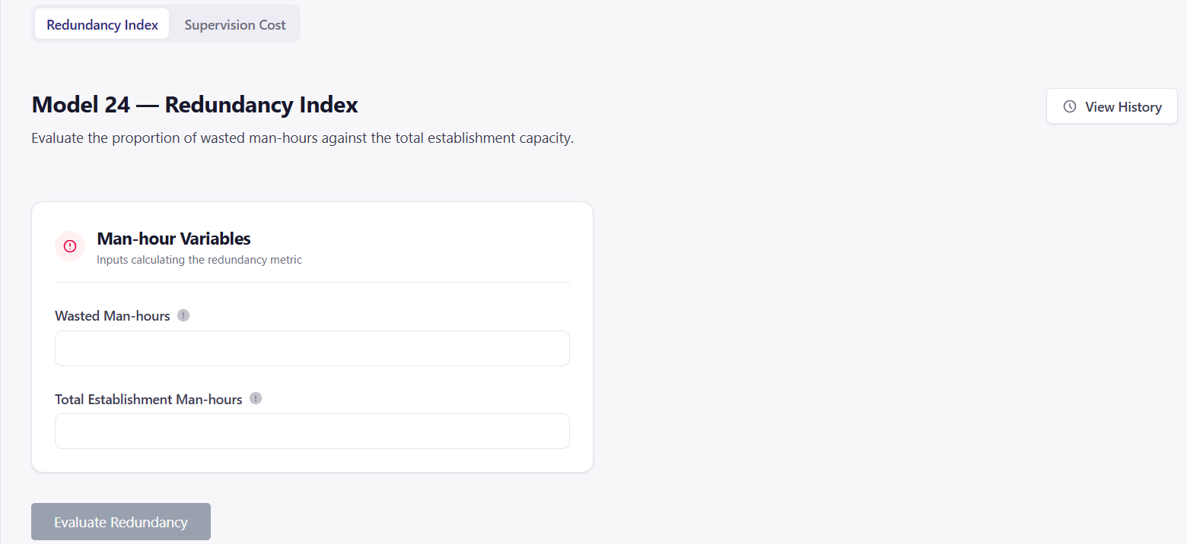
Fig. 5.3
You will find that to run this model the wasted Man-hour (D*) values is needed and we will also need it for the organization structure model. Just take note. You will find that optimal D* is the value needed here why the sane two values D* and K* are the two values in the above figure that was evaluated earlier which will be used to determine the redundancy in management level in the organization model. I would love they are given the opportunity to select from the Redundancy history which of these computed and recorded values they want to fill the Optimal wasted Hrs (D*) field above and the Optimal wasted Hrs (D*) and the Optimal personnel (K*) in the organization structure model.
6. Please I will like that you include in the Redundancy Index history data recorded the following variables D*(min), K*, the $λ$ and the $μ$ that provided the wasted-man hour value pulled for use from fig 5.2 which was fed into figure 5.3 and also include the remove button for each recorded data stored in the figure below
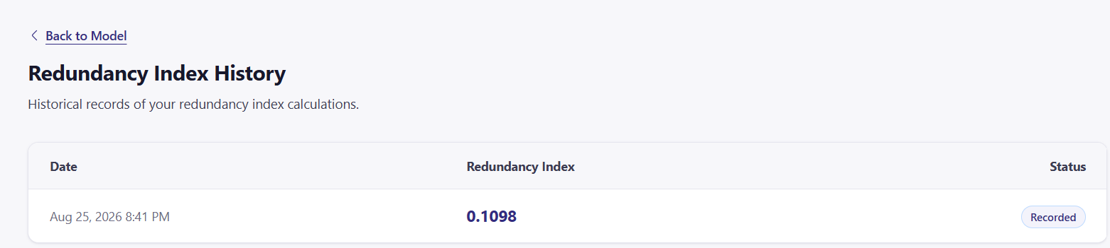
7. Please I will like that you include in the Productivity Index history data recorded the following Output Resources (un-inflated) value and the input Resources (un-inflated) that was used to get the Productivity index result because a good history record will be needed for predicting into the future in another model the actual increase of product and also include the remove button for each recorded data stored in the figure below
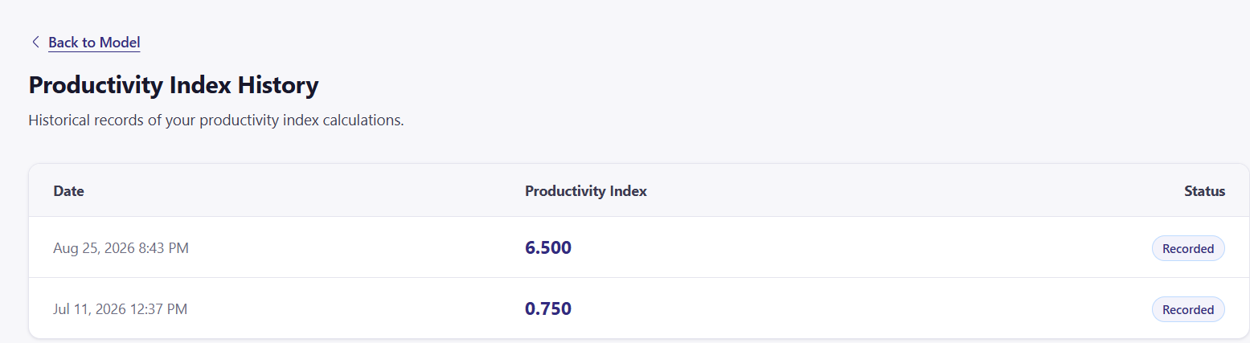
8. A new model will be added that will contain the records of the as the history from item 4 and 7 above that are highlighted in red. Then the section -22 Future requirements – which the other developer did in the organization structure be used for the model where a-intercept, b-gradient and X-volume is to be determine from the history record for which ever future prediction is needed to be determined either the production level output in the future (Using the pull from the Productivity index history or the actual required staff needed in the future for both the Student teacher model and the organization structure model)
How to the a, b and x values from the models mentioned to be used.
- For the Student teacher model we need the teachers number and the K* value obtained from the run model stored in the history to determine the X-Student Volume predicted for the future. The plot of the teachers-y axis against the K*-x axis be plotted and a best linear fit-line inserted with which where the line intersect the y axis is filled into the a-intersect field and the slope of the best fit linear line filled into the b-gradient field. Once these two results are obtained then we can extrapolate to find what the required teachers number will be for any other K* value will be and from there determine the required number of students for that K* (student/teacher ratio)
- The above is very similar for staff number model, we need the total staff numbers (from supervisory to management level) and the K* values obtained from the run model stored in the history of the personnel utilization model history. We can then use the K* values and their corresponding management staff numbers determine to plot the scatter plot graph and a best linear fit-line inserted with which where the line intersect the y axis is filled into the a-intersect field and the slope of the best fit linear line filled into the b-gradient field. Once these two results are obtained then we can extrapolate to find what the required total staff number will be for any future year.
- The above is very similar for production index model, we need to plot the graph of the previous Output Resources (un-inflated) and that of the corresponding productivity index and a best linear fit-line inserted with which where the line intersect the y axis is filled into the a-intersect field and the slope of the best fit linear line filled into the b-gradient field. Once these two results are obtained then we can extrapolate to find what the predicted Output Resources for any future period.
9. For the organization structure model, I will explain how this is to be designed. Let’s see the first section of what the former developer did as shown in the figure below.
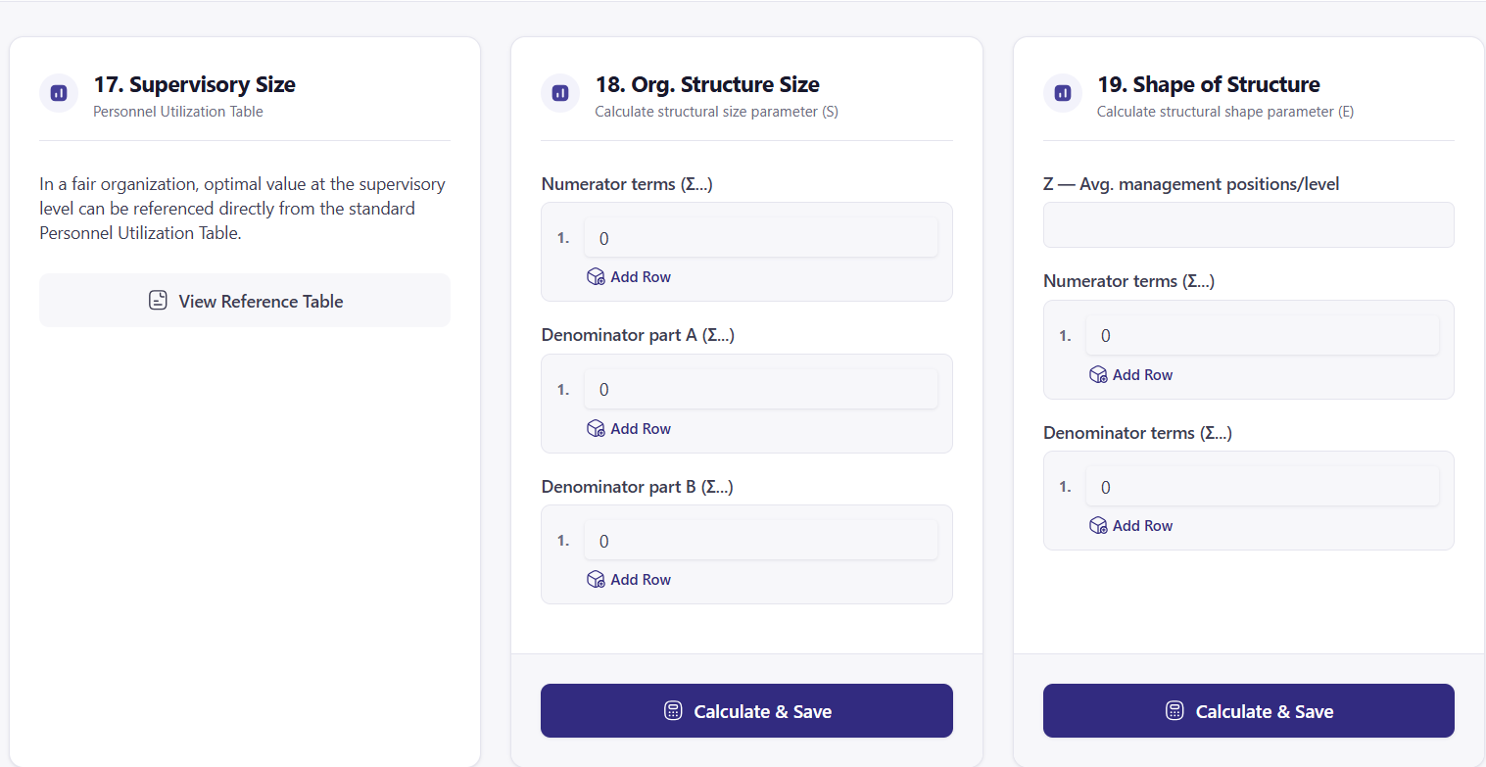
For 17-Supervisory size we need under this section the result from the staff number model (which ever of the three available to the which they have used i.e i. Plain estimation or ii. factor estimation or iii. work sample) and the K* result from the personnel Utilization model. So let this section carry a table showing these. Then the software divide the selected result obtained (i.e. i. number of staff from Plain estimation or ii. factor estimation or iii. work sample) by the K* value obtained from the Personnel Utilization model. This should give us a value No-1 as a result. This No-1 value will now be the result for the number of management level 1 at the bottom of section of 18. This No-1 result at management level 1 now will be the numerator at the second level above level 1 and it is expected that a new value of $λ$ and $μ$ must be supplied for that level and used to run the personnel utilization model to get it’s own K* which will now be used to divide No-1 brought to this level as the numerator which will provide No-2 as the number of management staff needed at level 2. This No-2 result at management level 2 now will be the numerator at the third level above level 2 and it is expected that a new value of $λ$ and $μ$ must be supplied for that level and used to run the personnel utilization model to get it’s own K* which will now be used to divide No-2 brought to this level as the numerator which will provide No-3 as the number of management staff needed at level 3. This process will continue until No-n result is 1. The total number n of this process done will determine the shape of the structure in 19-Shape of structure. Where n: 0, 1, 2, 3, ….. which will be used to fill the denominator in 19-Shape of Structure. And all the corresponding values of No-1,2,3…… as related to n will be filled in the numerator of 19-Shape of Structure. At this stage there is no more computation or calculation to be done, we only save the stature obtained.
For section 21-Percentage redundancy, you will see how this is obtained in page 79 of the full and complete document I gave you. There junior staff was written but actually its management staff because we only use $λ$ and $μ$ when we are determining management staff parameters. So the value of No-n that we obtain is the ideal number of staff which the real number of staff is what is presently in play at the organization. So for each management level we can determine out real percentage redundancy PR% and then with the formula at the bottom of that page 97 we can determine the personnel redundancy.
Remember for section-22 future requirement we have moved it to for a new model on the model menu.

